Cit Pecyn Ymarfer a Gweithgareddau (De) Uned 11
Practice and Activity Pack (South Wales) Unit 11

A. Beth yw’r rhain?

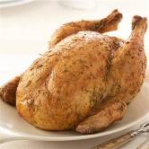

afal ______ ________ ______ ______ __________

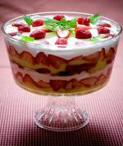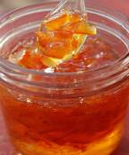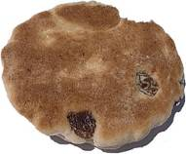

______________ ________________ ________________ __________

B. Llenwch y bylchau ac atebwch y cwestiynau

Beth ________ ti __ frecwast heddiw?

____________________________________

Beth ________ ____ __ ginio ddoe?

_____________________________________

________ ________ ____ i swper neithiwr?

_____________________________________

________ __________ ____ dydd Sul? (gwneud)

_____________________________________

C. Cyfieithwch

Well done, dear. ____ ________ ____. 

How lovely! ________ ____________! 
Very healthy indeed. ________ ________, ______. 

Are you sure? ______ _______ ________? 

That’s not good for you. ______ __________ ________ ____ ______ __ ____. 

Dych chi wedi defnyddio’r ymadrodd gyda’ch plentyn eto? Pan fyddwch chi, ticiwch y bocs!

Ch. Llenwch y grid

today |  | yesterday afternoon
this morning |  | last night
this afternoon |  | tomorrow
tonight |  | tomorrow morning
yesterday |  | tomorrow afternoon
yesterday morning |  | tomorrow night

D. Treigladau Mutations

Pysgod → Ga’i __ysgod?
Twrci → Ga’i __wrci?
Creision → Ga’i __reision?

Gyda’ch plentyn

1. Gêm holi ac ateb – Question and answer game
- This game is for two players, and is suitable for a child who is old enough to read the days of the week and brecwast, cinio, swper . Prepare an egg timer, or use the alarm on your phone
- Set the timer to four minutes
- Players take it in turns to ask each other Beth gest ti i [frecwast] [dydd Llun]? etc. If there are any items in the relevant box, the other player must say them. If not, the answer is Dim byd (nothing)
- A player gets a point if the other player answers one item, two points for two items, and no points for a Dim byd
- When the alarm rings, stop playing. The player with the most points wins.

 | brecwast | cinio | swper |  |  |  | brecwast | cinio | swper
Llun |  | 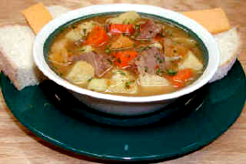 |  |  |  | Llun |  |  | 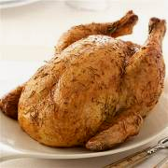
Mawrth | 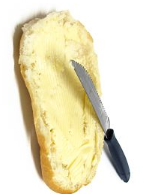 |  |  |  |  | Mawrth |  | 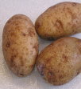
Mercher |  |  | 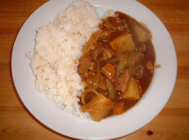 |  |  | Mercher |  |  | 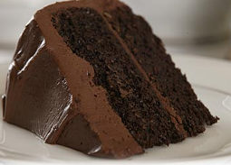
Iau | 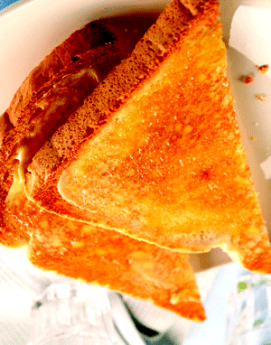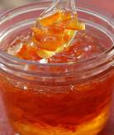 |  | 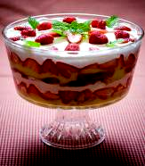 |  |  | Iau |  | 
Gwener |  | 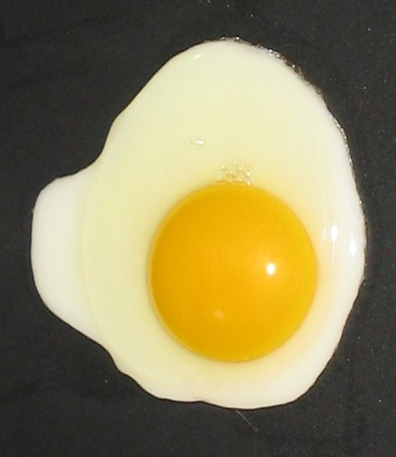 |  |  |  | Gwener | 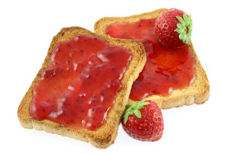 | 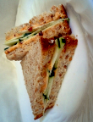 | 
Sadwrn |  |  |  |  |  | Sadwrn | 
Sul | 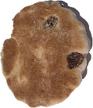 |  |  |  |  | Sul |  |  | 

